Assignment-25.4:

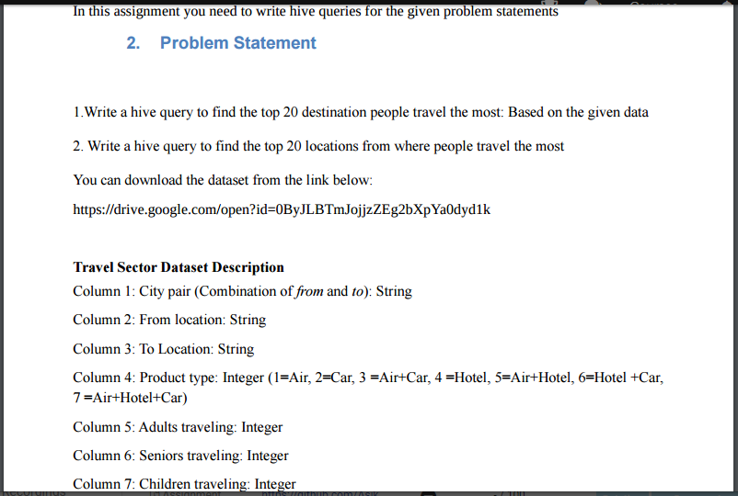

A table named travel is created with the given columns. Then the data is loaded and displayed using the select command.

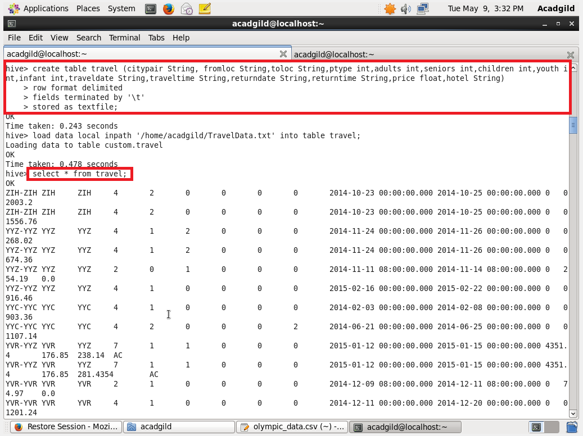

1. Write a hive query to find the top 20 destination people travel the most: Based on the given data

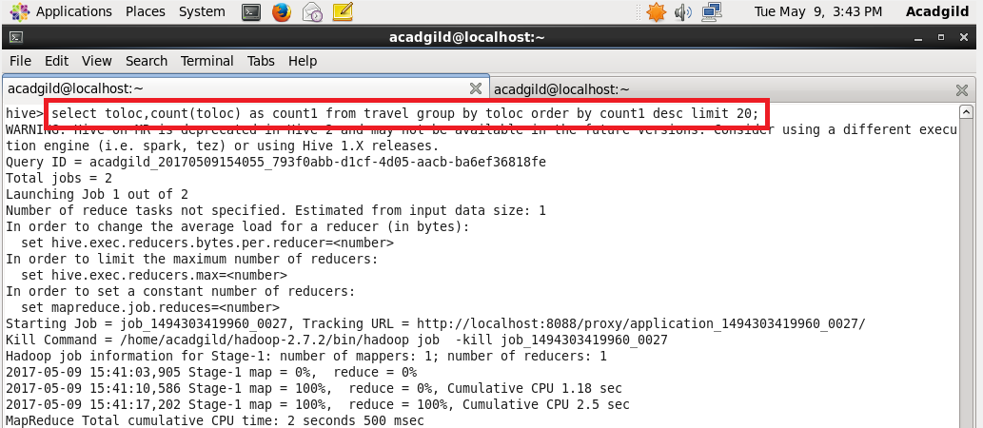

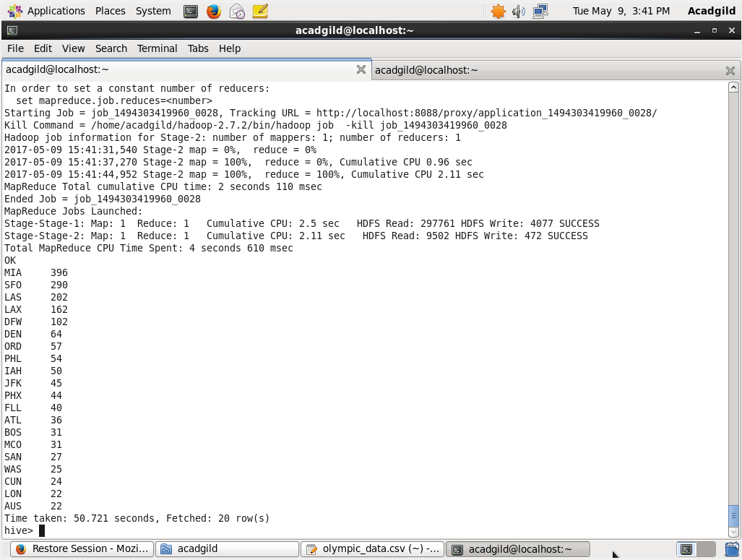

2. Write a hive query to find the top 20 locations from where people travel the most

